EXERCISE NO : 11

DATE : 23/11/2020

AIM :

To write a python program obtain Greatest Common Divisor (GCD)

of two given numbers.

PROGRAM :

def gcd(a,b):

if(a==0):

return a

if(b==0):

return b

if(a==b):

return b

if(a>b):

return(gcd(a-b,b))

else:

return gcd(a,b-a)

a=int(input("Enter first number:"))

b=int(input("Enter second number:"))

GCD=gcd(a,b)

print("GCD is:")

print(GCD)

OUTPUT :

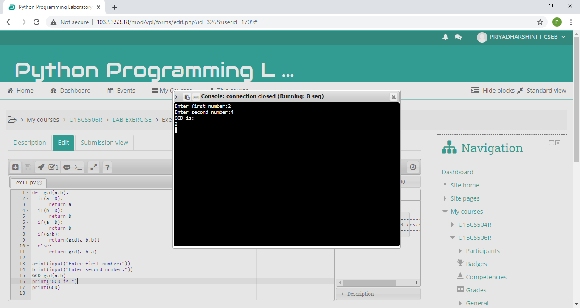

LINK :

<http://103.53.53.18/mod/vpl/forms/edit.php?id=326&userid=1709#>

RESULT :

Thus , the program is successfully executed and output is verified.